Design Guidance

<https://wsdemos.uc.r.appspot.com/burger>

amp-story-page {

font-family: 'Poppins', sans-serif;

color: white;

}

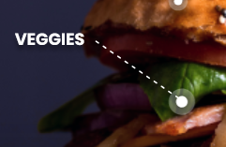

.food-label {

font-weight: bold;

font-size: .8em; font-size: 14.08px;

width: 23%;

line-height: 1.1em;

position: absolute;

text-shadow: 0px 4px 4px rgba(0, 0, 0, 0.4);

}



h1.title {

font-weight: bold;

font-size: 1.75em;

position: absolute;

width: 83%;

left: 12%;

top: 10%;

}



h2.subtitle {

font-weight: bold;

font-size: .9em;

text-align: center;

position: absolute;

width: 85%;

left: 7.5%;

top: 18%;

background: url('burger/assets/banner.svg');

background-position-x: 0%;

background-position-y: 0%;

background-repeat: repeat;

background-size: auto;

background-size: contain;

background-repeat: no-repeat;

background-position: center;

line-height: 2em;

color: #282843;

}

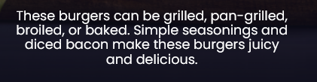

h3.footer {

font-size: .8em; 14.08px

font-weight: normal;

text-align: center;

width: 70%;

position: absolute;

left: 15%;

top: 85%;

line-height: 1.1em; 15.4833px

position: absolute;

}

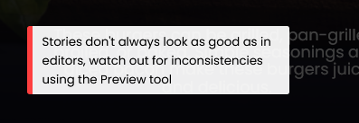

.wrong-footer {

font-weight: normal;

font-size: 0.6em;

background: #ffffffee;

color: black;

width: 22em;

border-left: 0.5em solid rgb(254, 63, 63);

position: absolute;

left: 10%;

top: 85%;

padding: 0.5em 0.8em;